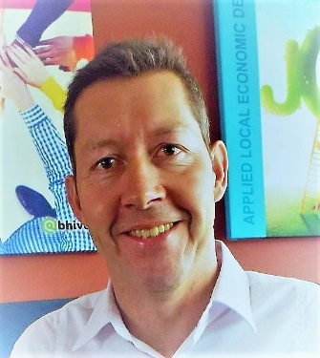
Prof Daniel F Meyer, short CV,
ORCID: 0000-0001-6715-7545.
Prof Daniel Meyer is a professor at the College of Business and Economics (CBE) at the University of Johannesburg (UJ), South Africa. He is a National Research Foundation (NRF) rated researcher with a focus on the development of measurement tools and indices. Daniel is a Development Economist and a specialist in regional and local economic development analysis and policy development. He has developed a range of innovative measurement tools, indices, and scales to analyse regional economies. He also has a research focus on macroeconomics and the linkages with good governance. He has authored more than 190 peer-reviewed research papers since 2014 and has presented more than 70 papers at international conferences, including several keynote addresses. His research is multidisciplinary, combining development economics, business, public management, and governance. He has established a large international network of research partners with a strong focus on the Visegrad group of countries (Czech Republic, Hungary, Poland, Slovakia), Lithuania, the US, Malaysia, Indonesia, India and the Maldives. Locally, he also has an extensive network with various municipalities and national institutions such as COGTA, SALGA, LGSETA, CSIR, ISA, and Kagiso Trust. He has also successfully completed and delivered more than 40 regional development strategies for local and provincial governments. He is active in the media, with regular opinion pieces, and is involved in media interviews and discussions. He is also involved in various community development projects in his communities. During his academic career, he has received several awards, which include the most inspiring lecturer in 2012, Vice-Chancellor’s Award for Community Engagement via the Vaal LED Warrior Initiative in 2016, Media Person of the Year in 2016, and Most Productive Senior Researcher in the NWU Vaal campus in 2016, 2017 and 2018; most productive senior researcher in the NWU Faculty of Economic and Management Sciences in 2019; runner-up most productive senior researcher in 2020 at NWU; and top 10 research award in the College of Business and Economics at UJ in 2022, 2023 and 2024. His motto in life is “Give more than you take”……

